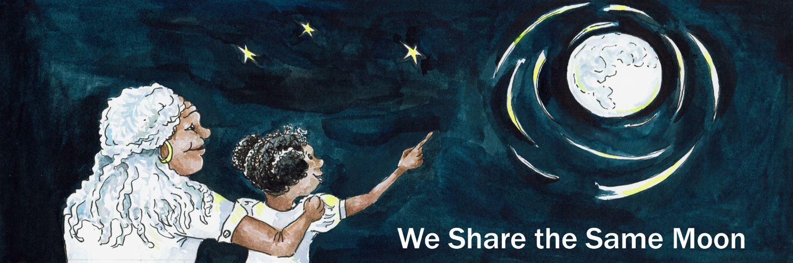
Suggested Age Range: 7 - 8 years; 8 - 9 years; 9 -10 years; 10 - 11 years
Suggested UK Year Group: Year 3, Year 6
UK Curriculum: KS2
UK Primary Curriculum Link: Light
Science Subject: Eclipse
Science Question: Why do we have eclipses?
Suggested Science Activity: Eclipses
Children with SEND: Use to boost comprehension of science vocabulary
EAL children: Beginners level
Country of Origin: Peru
Source: Source: When Jaguars Ate the Moon by Maria Cristina Brusca

Have YOU ever wondered why - the Moon sometimes look red in the Sky?
Maybe you have never seen it, maybe you have never thought to look?
But sometimes, when there is what we call a lunar eclipse, the Moon looks red in the sky. Because, when the Moon moves into the earth’s shadow, the Sun’s rays are blocked from reaching the Moon. Only some of the Sun’s light, which can sneak around the sides of the Earth, can reach the Moon. And these rays of light are red, which makes the Moon turn bright red - as if it were covered in blood.
At least, that is what the scientists say …

But the people of Toba - they say something different!
Long ago when the world began, long before there was the country called Peru…
The people of Toba lived in the Amazon rainforest, that covered the land beneath the tall, tall mountains we call The Andes. The Toba people thought the Moon was a pot-bellied old man. On the night of the Dark Moon, when no Moon is visible in the Sky, the Toba people used to say that the Old Man was off hunting for food.
Once he returns from his hunting and begins to eat his food - then he grows fatter and fatter and fatter in the sky. Until of course he begins to run out of food!
And then ,he starts to get slimmer and slimmer and thinner and thinner - until all the food has gone. And then he has to go hunting again!
And that is why the Old Man Moon changes shape every night, depending on how much food he has eaten.
One night …
When the Old Man Moon was full of food and shining bright with contentment, as you do, after a good meal, down on Earth, all was quiet, all was quiet in the forest for everyone was asleep. Everyone that is …EXCEPT for the Jaguars!
The fastest and fiercest cats in the whole of the Amazon forest!
The Jaguars were so hungry - they had not caught any food for days.
They looked at the Moon …
The Old Man Moon, he looked very tasty, up there in the sky!
The Jaguars licked their lips hungrily, the Jaguars flexed their claws carefully.
The Jaguars looked at one another, and then up to the sky, and slowly their tails began to twitch to and fro, to and fro … And then they crouched and then they leapt! Up into the air and onto the staircase of stars!
They leapt from star to star, to star, closer and closer and closer to the Old `Man Moon.
And then they crouched and then they pounced!
And bit the poor Old Man Moon on the nose! Ouch! And it hurt - very much!
OUCH! cried the Moon, as the blood ran down his nose and over his body.
Ouch, ouch, ouch, ouch, OUCH!
The people of Toba woke up! What was that noise?
They ran outside, they saw the Moon glowing red, they saw the Jaguars trying to eat him.
They had to help!
They ran back inside, grabbed their pots and pans and ran back out again!
And began banging their pots and pans with a spoon, beating a rhythm as loudly as they could.
Ba, ba, ba, ba boom, ba, ba, ba boom! Ba, ba, ba, ba boom, ba, ba, ba boom!
Ba, ba, ba, ba boom, ba, ba, ba boom!
The little children hit the smaller pans, the elder people beat the great big pans!
And together they beat:
Ba, ba, ba, ba boom, ba, ba, ba boom! Ba, ba, ba, ba boom, ba, ba, ba boom!
Ba, ba, ba, ba boom, ba, ba, ba boom!
They made such a fearful noise!
Ba, ba, ba, ba boom, ba, ba, ba boom! Ba, ba, ba, ba boom, ba, ba, ba boom!
Ba, ba, ba, ba boom!
The noise was so loud, the Jaguars were terrified!
And they let go of the Moon! And slid all the way back down to Earth!
And slunk back into the forest, with their beautiful tails between their beautiful legs.
The Toba people went back to sleep.
BUT … if ever the Moon turns red, they know what to do!
They grab their pots, they grab their pans, they grab their spoons and they:
Ba, ba, ba, ba boom, ba, ba, ba boom!
Ba, ba, ba, ba boom, ba, ba, ba boom!
And that is why the Moon turns red - whenever the Jaguars grow hungry and need to be fed!
Or at least - that was what I was told!
Copyright Cassandra Wye, 2017, on behalf of The Lunar Planetary Institute, USA
Created for The Vanishing Sun https://www.lpi.usra.edu/education/explore/eclipse/

